1.1 - Automate development tasks by using GitHub Actions
How does GitHub Actions automate development tasks?

GitHub decreases time from idea to deployment
GitHub is designed to help teams of developers and DevOps engineers build and deploy applications quickly. There are many features in GitHub that enable these efficiencies, but they generally fall into one of two categories:
- Communication: Consider all of the ways that GitHub makes it easy for a team of developers to communicate about the software development project: code reviews in pull requests, GitHub issues, project boards, wikis, notifications, and so on.
- Automation: GitHub Actions lets your team automate workflows at every step in the software-development process, from integration to delivery to deployment. It even lets you automate adding labels to pull requests and checking for stale issues and pull requests.

What is GitHub Actions?
GitHub Actions are packaged scripts to automate tasks in a software-development workflow in GitHub. You can configure GitHub Actions to trigger complex workflows that meet your organization's needs. The trigger can happen each time developers check new source code into a specific branch, at timed intervals, or manually. The result is a reliable and sustainable automated workflow, which leads to a significant decrease in development time.

Where can you find GitHub Actions?
GitHub Actions are scripts that adhere to a yml data format. Each repository has an Actions tab that provides a quick and easy way to get started with setting up your first script. If you see a workflow that you think might be a great starting point, just select the Configure button to add the script and begin editing the source yml.
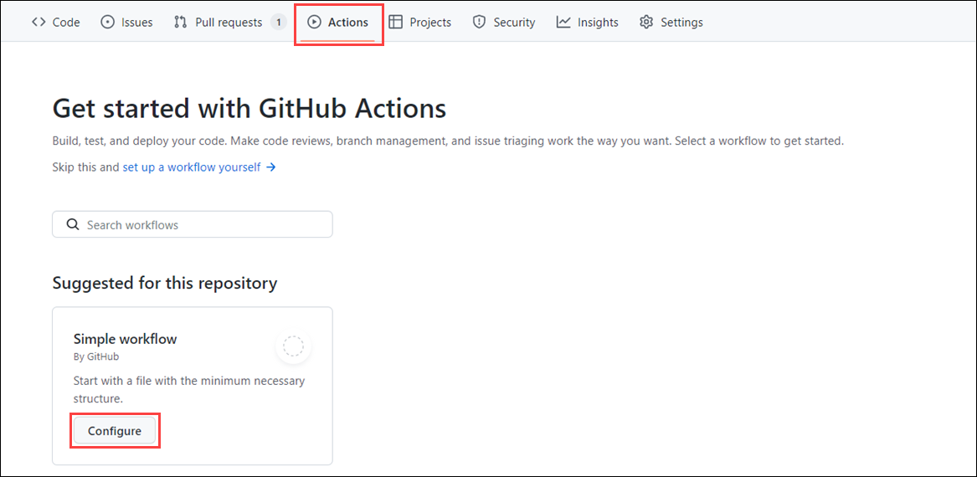

Using open-source GitHub Actions
Many GitHub Actions are open source and available for anyone who wants to use them. However, just like with any open-source software, you need to carefully check them before using them in your project. Similar to recommended community standards with open-source software such as including a README, code of conduct, contributing file, and issue templates, you can follow these recommendations when using GitHub Actions:
- Review the action's action.yml file for inputs, outputs, and to make sure the code does what it says it does.
- Check if the action is in the GitHub Marketplace. This check is worthwhile, even if an action doesn't have to be on the GitHub Marketplace to be valid.
- Check if the action is verified in the GitHub Marketplace. Verification means that GitHub approved the use of this action. However, you should still review it before using it.
- Include the version of the action you're using by specifying a Git ref, SHA, or tag.

Types of GitHub actions
There are three types of GitHub actions: container actions, JavaScript actions, and composite actions.
- Container actions, the environment is part of the action's code. These actions can only be run in a Linux environment that GitHub hosts. Container actions support many different languages.
- JavaScript actions don't include the environment in the code. You have to specify the environment to execute these actions. You can run these actions in a VM (virtual machine) in the cloud or on-premises. JavaScript actions support Linux, macOS, and Windows environments.
- Composite actions allow you to combine multiple workflow steps within one action. For example, you can use this feature to bundle together multiple run commands into an action, and then have a workflow that executes the bundled commands as a single step using that action.

What is a GitHub Actions workflow?
- A GitHub Actions workflow is a process that you set up in your repository to automate software-development lifecycle tasks, including GitHub Actions. With a workflow, you can build, test, package, release, and deploy any project on GitHub.
- To create a workflow, you add actions to a .yml file in the .github/workflows directory in your GitHub repository.
- A workflow must have at least one job. A job is a section of the workflow associated with a runner. A runner can be GitHub-hosted or self-hosted, and the job can run on a machine or in a container. You specify the runner with the runs-on: attribute. Here, you're telling the workflow to run this job on ubuntu-latest.
- Each job has steps to complete.
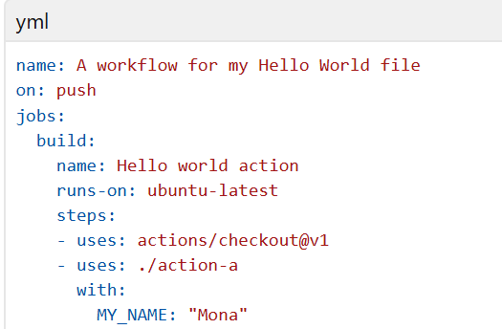

Referencing actions in workflows
When creating workflows in GitHub Actions, you can reference actions from various sources. These actions can be used to automate tasks in your workflows. Below are the primary sources where workflows can reference actions:
- A published Docker container image on Docker Hub
  - Workflows can reference actions that are published as Docker container images on Docker Hub. These actions are containerized and include all dependencies required to execute the action. To use such an action, you specify the Docker image in the uses attribute of your workflow step.
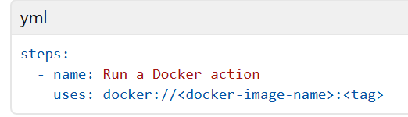
- Any public repository
  - Actions hosted in public repositories can be directly referenced in your workflows. These actions are accessible to anyone and can be used by specifying the repository name and version (Git ref, SHA, or tag) in the uses attribute.
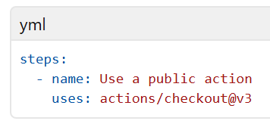
- The same repository as your workflow file
  - You can reference actions stored in the same repository as your workflow file. This feature is useful for custom actions that are specific to your project. To reference such actions, use a relative path to the action's directory.
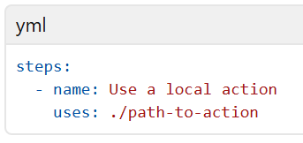

- An enterprise marketplace
  - If your organization uses GitHub Enterprise, you can reference actions from your enterprise's private marketplace. These actions are curated and managed by your organization, ensuring compliance with internal standards.
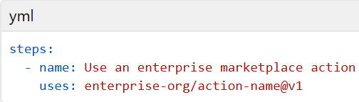

Actions in private repositories can also be referenced, but they require proper authentication and permissions.
When referencing actions, always specify a version (Git ref, SHA, or tag) to ensure consistency and avoid unexpected changes.

GitHub-hosted versus self-hosted runners
- A runner is simply a server that has the GitHub Actions runner application installed. There are two options from which to choose: GitHub-hosted runners or self-hosted runners.
- If you use a GitHub-hosted runner, each job runs in a fresh instance of a virtual environment. The GitHub-hosted runner type you define, runs-on: {operating system-version} then specifies that environment.
- With self-hosted runners, you need to apply the self-hosted label, its operating system, and the system architecture. For example, a self-hosted runner with a Linux operating system and ARM32 architecture would look like the following specification: runs-on: [self-hosted, linux, ARM32].

GitHub Actions can have usage limits
GitHub Actions does have some usage limits, depending on your GitHub plan and whether your runner is GitHub-hosted or self-hosted.

GitHub hosted larger runners
GitHub offers larger runners for workflows that require more resources. These runners are GitHub-hosted and provide increased CPU, memory, and disk space compared to standard runners. They're designed to handle resource-intensive workflows efficiently, ensuring optimal performance for demanding tasks.

Runner sizes and labels
Larger runners are available in multiple configurations, providing enhanced vCPUs, RAM, and SSD storage to meet diverse workflow requirements. These configurations are ideal for scenarios such as:
- Compiling large codebases with extensive source files.
- Running comprehensive test suites, including integration and end-to-end tests.
- Processing large datasets for data analysis or machine learning tasks.
- Building applications with complex dependencies or large binary outputs.
- Performing high-performance simulations or computational modeling.
- Executing video encoding, rendering, or other multimedia processing workflows.
To use a larger runner, specify the desired runner label in the runs-on attribute of your workflow file. For example, to use a runner with 16 vCPUs and 64 GB of RAM, you would set runs-on: ubuntu-latest-16core.
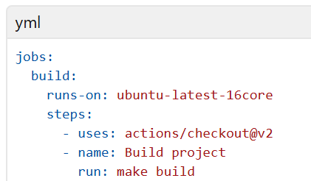

Managing larger runners
GitHub provides tools to manage larger runners effectively, ensuring optimal resource utilization and cost management. Here are some key aspects of managing larger runners:
- Monitoring usage
  - You can monitor the usage of larger runners through the GitHub Actions usage page in your repository or organization settings. This page provides insights into the number of jobs run, the total runtime, and the associated costs.
- Managing access
  - To control access to larger runners, you can configure repository or organization-level policies. This configuration ensures that only authorized workflows or teams can use these high-resource runners.
- Cost management
  - Larger runners incur extra costs based on their usage. To manage costs, consider the following suggestions:
    - Use larger runners only for workflows that require high resources.
    - Reduce runtime by optimizing workflows.
    - Monitor billing details regularly to track expenses.
- Scaling workflows
  - If your workflows require frequent use of larger runners, consider scaling strategies such as:
    - Using self-hosted runners for predictable workloads.
    - Splitting workflows into smaller jobs to distribute the load across standard runners.

The components of GitHub Actions
There are several components that work together to run tasks or jobs within a GitHub Actions workflow. In short, an event triggers the workflow, which contains a job. This job then uses steps to dictate which actions will run within the workflow.
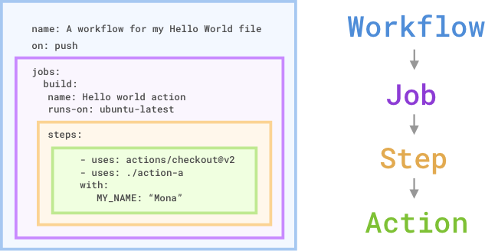

Workflows
A workflow is an automated process that you add to your repository. A workflow needs to have at least one job, and different events can trigger it. You can use it to build, test, package, release, or deploy your repository's project on GitHub.

Jobs
The job is the first major component within the workflow. A job is a section of the workflow that will be associated with a runner. A runner can be GitHub-hosted or self-hosted, and the job can run on a machine or in a container. You'll specify the runner with the runs-on: attribute. Here, you're telling the workflow to run this job on ubuntu-latest.

Steps
A step is an individual task that can run commands in a job. In our preceding example, the step uses the action actions/checkout@v2 to check out the repository. What's interesting is the uses: ./action-a value. This is the path to the container action that you'll build in an action.yml file.

Actions
The actions inside your workflow are the standalone commands that are executed. These standalone commands can reference GitHub actions such as using your own custom actions, or community actions like the one we use in the preceding example, actions/checkout@v2. You can also run commands such as run: npm install -g bats to execute a command on the runner.

Configure a GitHub Actions workflow
Configure workflows to run for scheduled events
As mentioned previously, you can configure your workflows to run when specific activity occurs on GitHub, when an event outside of GitHub happens, or at a scheduled time. The schedule event allows you to trigger a workflow to run at specific UTC times using POSIX cron syntax. This cron syntax has five * fields, and each field represents a unit of time.
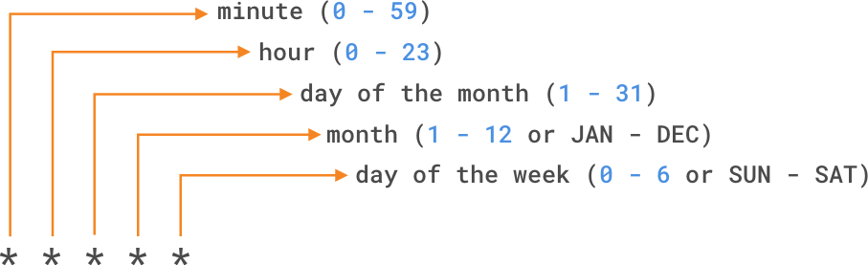
If you want to run a workflow every 15 minutes, the schedule event would look like
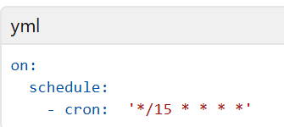
if you wanted to run a workflow every Sunday at 3:00am, the schedule event would look like this
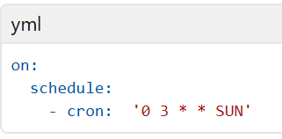
You can also use operators to specify a range of values or to dial in your scheduled workflow. The shortest interval you can run scheduled workflows is once every five minutes, and they run on the latest commit on the default or base branch.

Configure workflows to run for manual events
- In addition to scheduled events, you can manually trigger a workflow by using the workflow_dispatch event. This event allows you to run the workflow by using the GitHub REST API or by selecting the Run workflow button in the Actions tab within your repository on GitHub. Using workflow_dispatch, you can choose on which branch you want the workflow to run, and set optional inputs that GitHub presents as form elements in the UI.
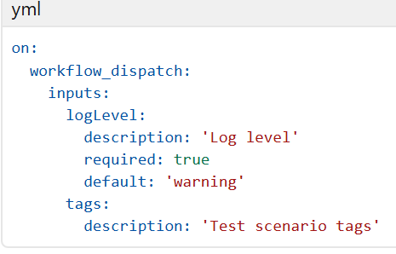
- In addition to workflow_dispatch, you can use the GitHub API to trigger a webhook event called repository_dispatch. This event allows you to trigger a workflow for activity that occurs outside of GitHub. It essentially serves as an HTTP request to your repository asking GitHub to trigger a workflow off an action or webhook. Using this manual event requires you to do two things: send a POST request to the GitHub endpoint /repos/{owner}/{repo}/dispatches with the webhook event names in the request body, and configure your workflow to use the repository_dispatch event.
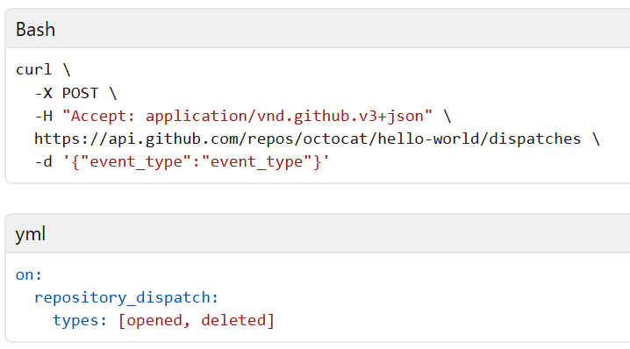

Configure workflows to run for webhook events
You can configure a workflow to run when specific webhook events occur on GitHub. You can trigger most webhook events from more than one activity for a webhook. If multiple activities exist for a webhook, you can specify an activity type to trigger the workflow. For example, you can run a workflow for the check_run event, but only for the rerequested or requested_action activity types.
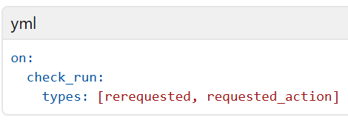

Disable and delete workflows
- After adding a workflow to your repository, you might find a situation where you want to temporarily disable the workflow. You can stop a workflow from being triggered without having to delete the file from the repo, either on GitHub or through the GitHub REST API. When you wish to enable the workflow again, you can easily do it using the same methods.
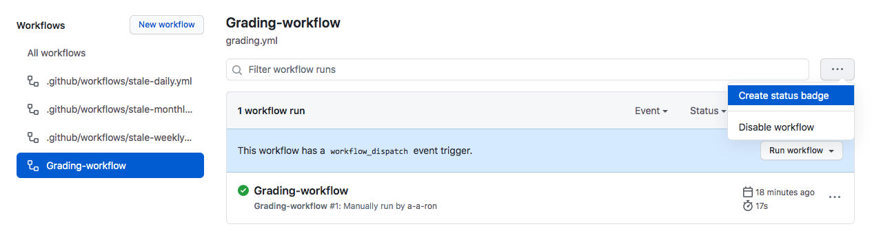
- Disabling a workflow can be useful in some of the following situations:
  - An error on a workflow is producing too many or wrong requests impacting external services negatively.
  - You want to temporarily pause a workflow that isn't critical and is consuming too many minutes on your account.
  - You want to pause a workflow that's sending requests to a service that is down.
  - You're working on a fork, and you don't need all the functionality of some workflows it includes (like scheduled workflows).
- You can also cancel a workflow run that's in progress in the GitHub UI from the Actions tab or by using the GitHub API endpoint DELETE /repos/{owner}/{repo}/actions/runs/{run_id}. Keep in mind that when you cancel a workflow run, GitHub cancels all of its jobs and steps within that run.

Use conditional keywords
- Within your workflow file, you can access context information and evaluate expressions. Although expressions are commonly used with the conditional if keyword in a workflow file to determine whether a step should run or not, you can use any supported context and expression to create a conditional. It's important to know that when using conditionals in your workflow, you need to use the specific syntax ${{ <expression> }}. This syntax tells GitHub to evaluate an expression rather than treat it as a string.
- For example, a workflow that uses the if conditional to check if the github.ref (the branch or tag ref that triggered the workflow run) matches refs/heads/main. In order to proceed, the workflow would look something like this:
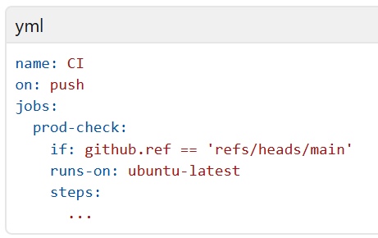
- Notice that in this example, the ${{ }} are missing from the syntax. With some expressions, like the if conditional, you can omit the expression syntax. GitHub automatically evaluates some of these common expressions, but you can always include them in case you forget which expressions GitHub automatically evaluates.

Use an organization's templated workflow
- If you have a workflow that multiple teams use within an organization, you don't need to re-create the same workflow for each repository. Instead, you can promote consistency across your organization by using a workflow template defined in the organization's .github repository. Any member within the organization can use an organization template workflow, and any repository within that organization has access to those template workflows.
- You can find these workflows by navigating to the Actions tab of a repository within the organization, selecting New workflow, and then finding the organization's workflow template section titled "Workflows created by organization name". For example, the organization called Mona has a template workflow as shown here.
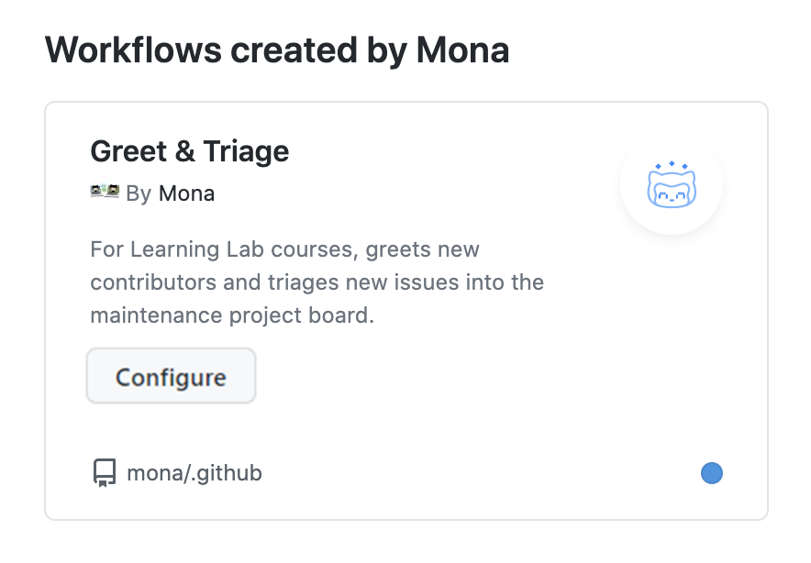

Use specific versions of an action
- When referencing actions in your workflow, we recommend that you refer to a specific version of that action rather than just the action itself. By referencing a specific version, you're placing a safeguard from unexpected changes pushed to the action that could potentially break your workflow. Here are several ways you can reference a specific version of an action:
- Some references are safer than others. For example, referencing a specific branch runs that action off of the latest changes from that branch, which you might or might not want. By referencing a specific version number or commit SHA hash, you're being more specific about the version of the action you're running. For more stability and security, we recommend that you use the commit SHA of a released action within your workflows.
